Choclates:

Calories:546

Proteins:4.9 g

Carbohydrates: 61 g

Fats: 31 g

Cholestrol: 8 mg

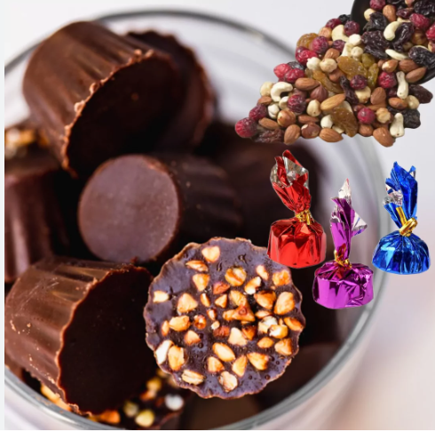

Manchuria:

Calories:837

Proteins:29 g

Carbohydrates: 30.9 g

Fats: 22.6 g

Cholestrol: 0 g

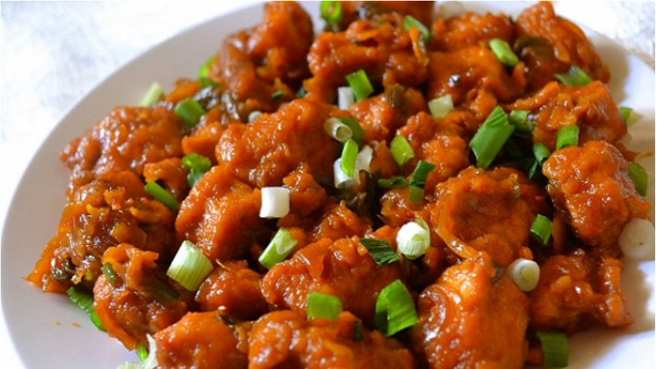

Noodles(100 grams):

Calories:138

Proteins:4.5 g

Carbohydrates: 25 g

Fats2.1 g

Cholestrol: 29 g

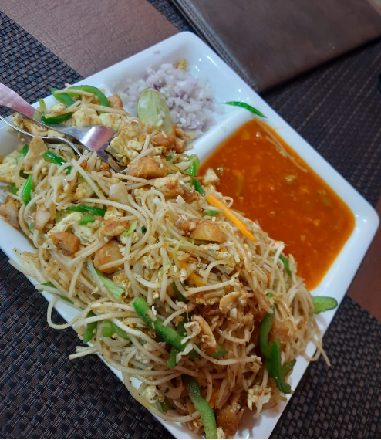

Pani puri:

Calories:329

Proteins:5.4 g

Carbohydrates: 29.6 g

Fiber: 3.6 g

Fats: 5.2 g

Cholestrol: 0 g

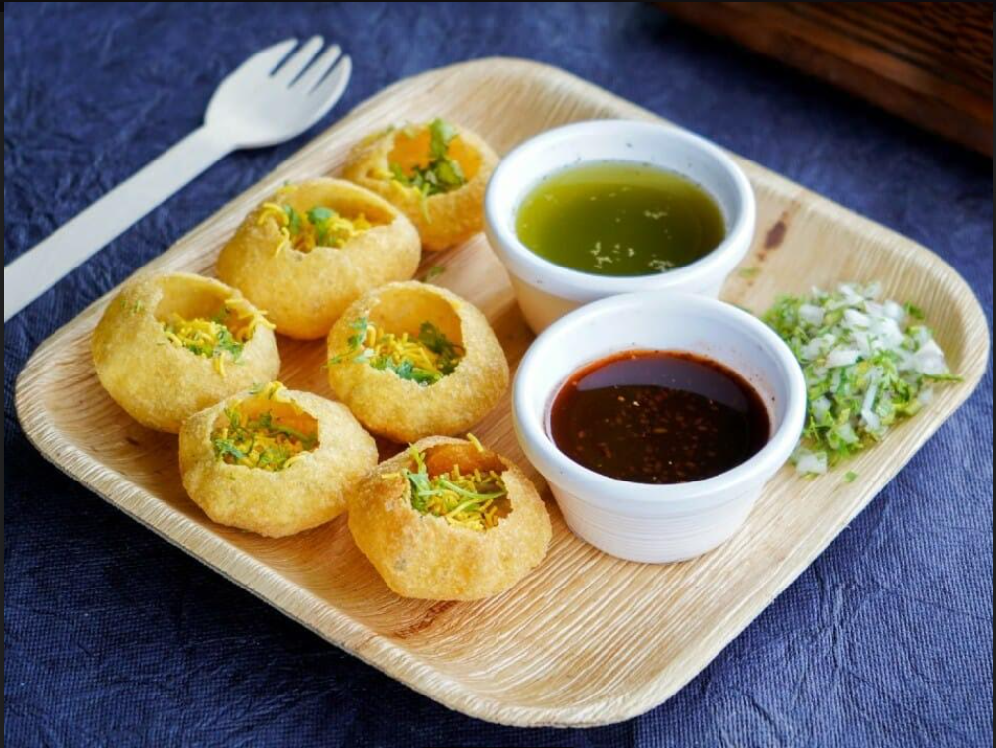

Ice Creams:

Calories:207

Proteins:3.5 g

Carbohydrates: 24 g

Fats: 11 g

Cholestrol: 44 mg

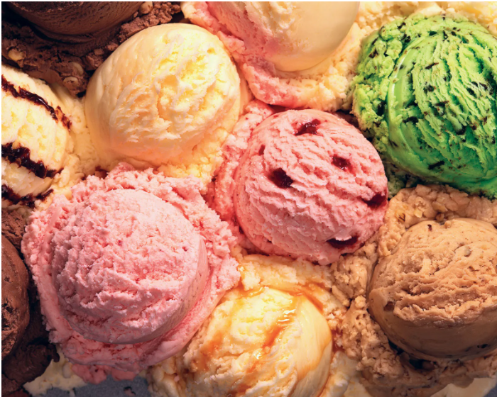

Milk Shakes(100 grams):

Calories:112

Proteins:3.9 g

Carbohydrates: 18 g

Fats: 3 g

Cholestrol: 50 g

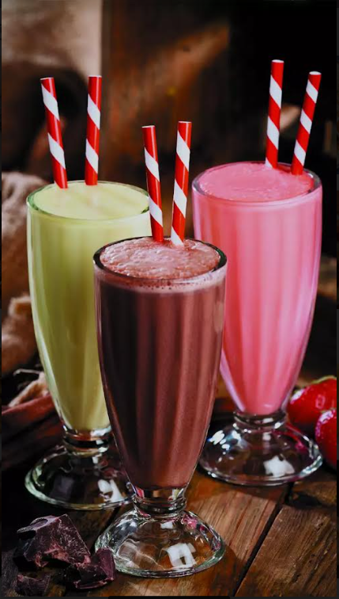

Sweets(100 grams):

Calories:535

Proteins:11 g

Carbohydrates: 59 g

Fats: 30 g

Cholestrol: 23 g

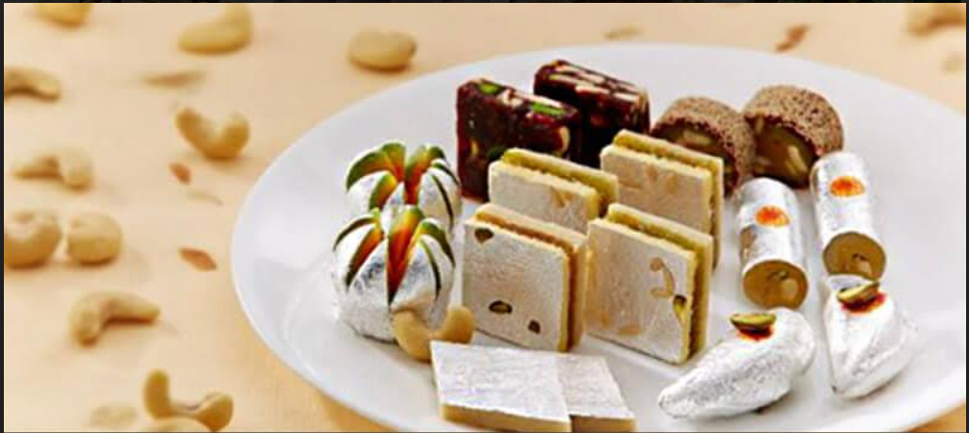

Pizza(100 grams):

Calories:243

Proteins:14 g

Carbohydrates: 40 g

Fats:10 g

Cholestrol: 17 mg

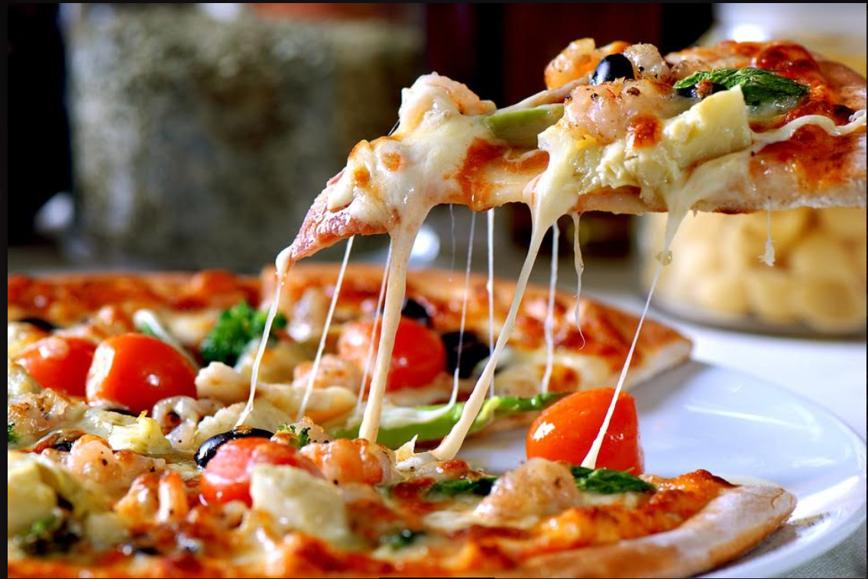

French Fries:

Calories:312

Proteins:3.4 g

Carbohydrates: 41 g

Fats: 15 g

Cholestrol: 0 g

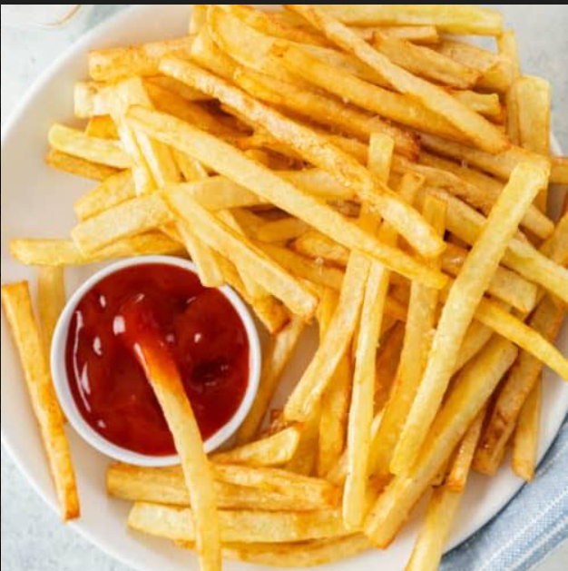

Burger:

Calories: 266

Fiber: 1.1g

Protein: 13.3 g

Carbs: 30.3 g

Fat:10.1 g

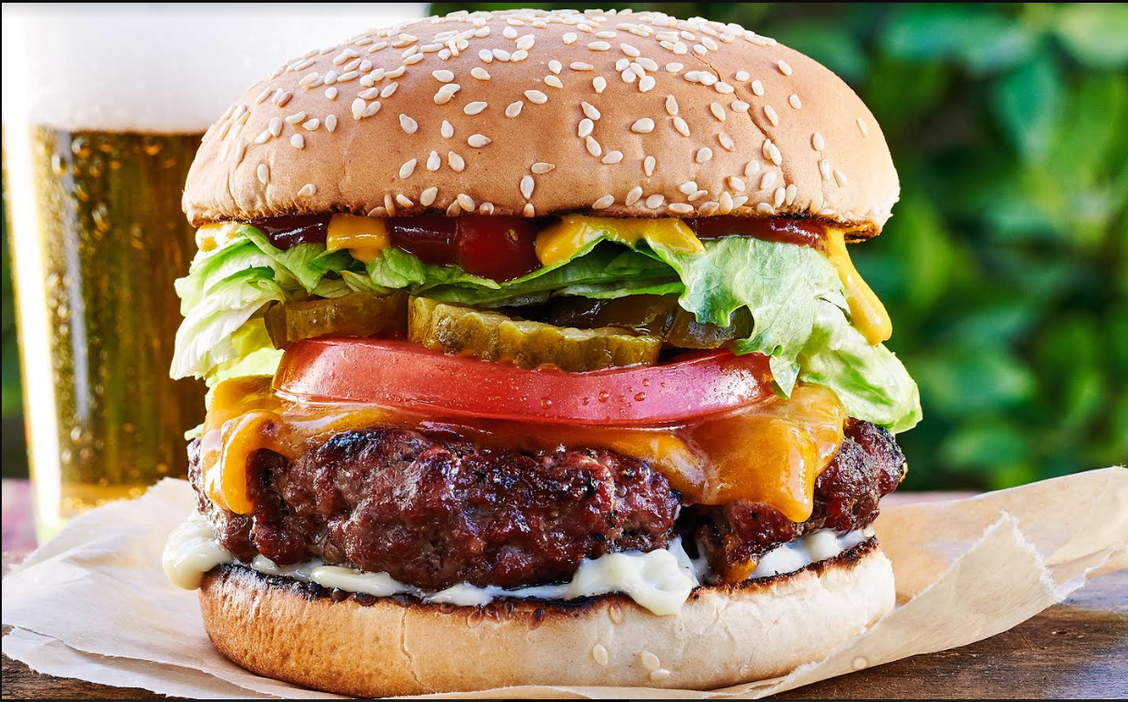

SandWich:

Calories:497

Proteins:10 g

Carbohydrates: 58 g

Fats: 25g

Cholestrol: 7 mg

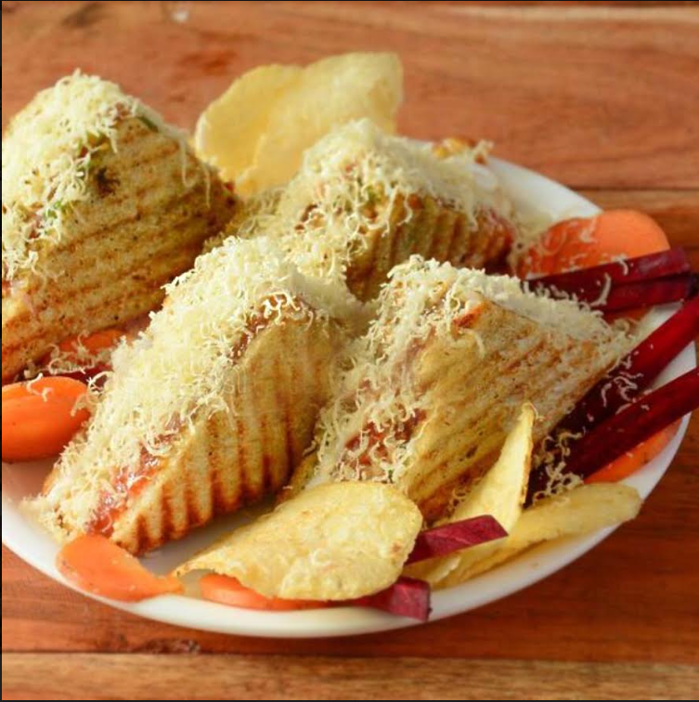

KFC( 1 Piece):

Calories:246

Proteins:39 g

Carbohydrates: 11 g

Sodium: 1190 mg

Fats: 19 g

Cholestrol: 82 mg

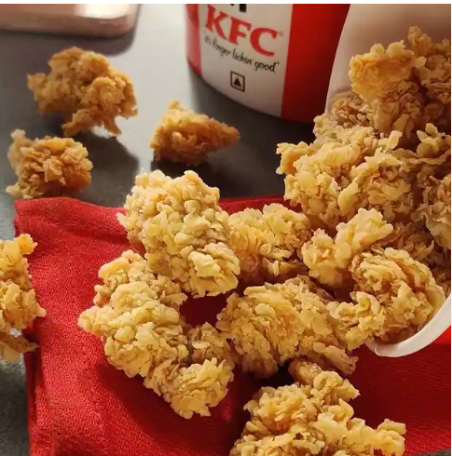

Chicken Biryani(500 grams):

Calories:360

Proteins:16 g

Carbohydrates: 56 g

Fats: 8 g

Cholestrol: 48 mg

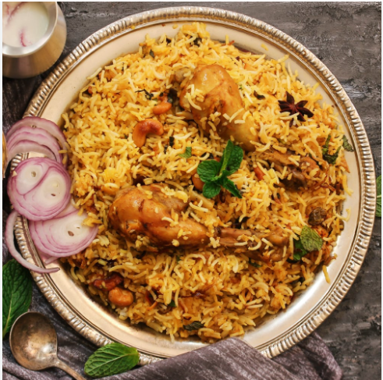

Mutton Biryani:

Calories:352

Proteins:27 g

Carbohydrates: 40 g

Fats: 10 g

Cholestrol: 45 mg

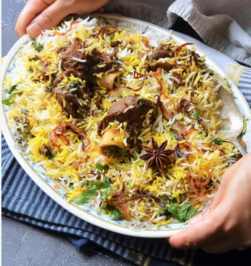

Prawns Biryani:

Calories:248

Proteins:14 g

Carbohydrates: 55 g

Fats: 3.9 g

Cholestrol: 45 g

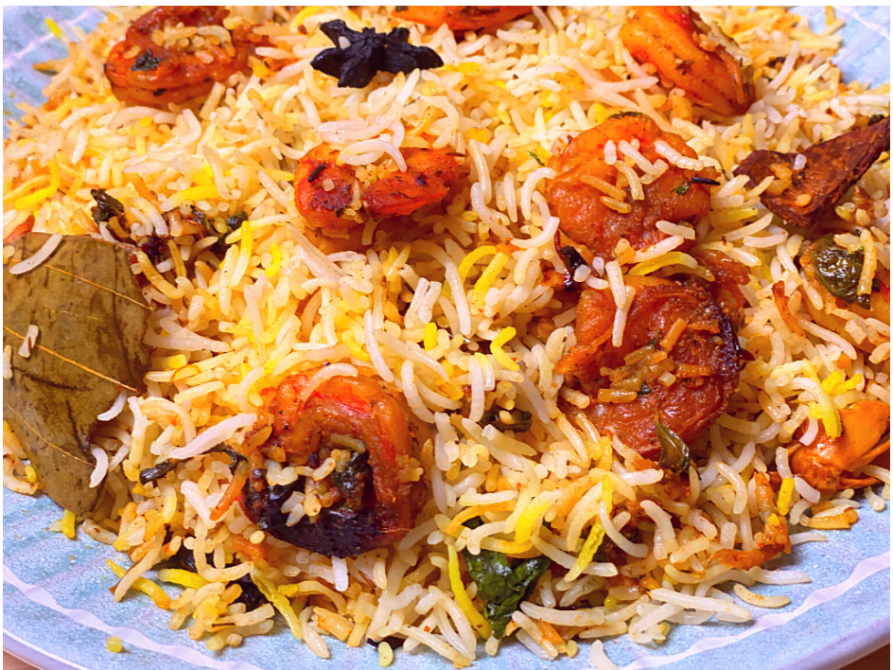

Fish Biryani:

Calories:383

Proteins:37.1 g

Carbohydrates: 67.8 g

Fats: 8.7 g

Cholestrol: 30.9 g

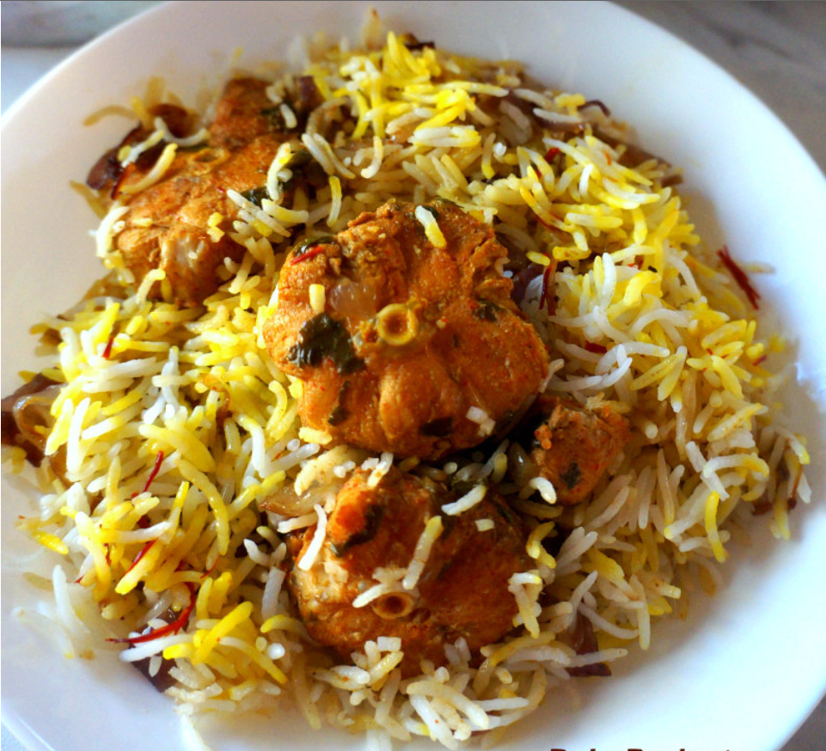

Chicken Lollipop(100 grams):

Calories:97

Proteins:17 g

Carbohydrates: 30.9 g

Fats: 22.6 g

Sodium:480 g

Cholestrol: 41 mg

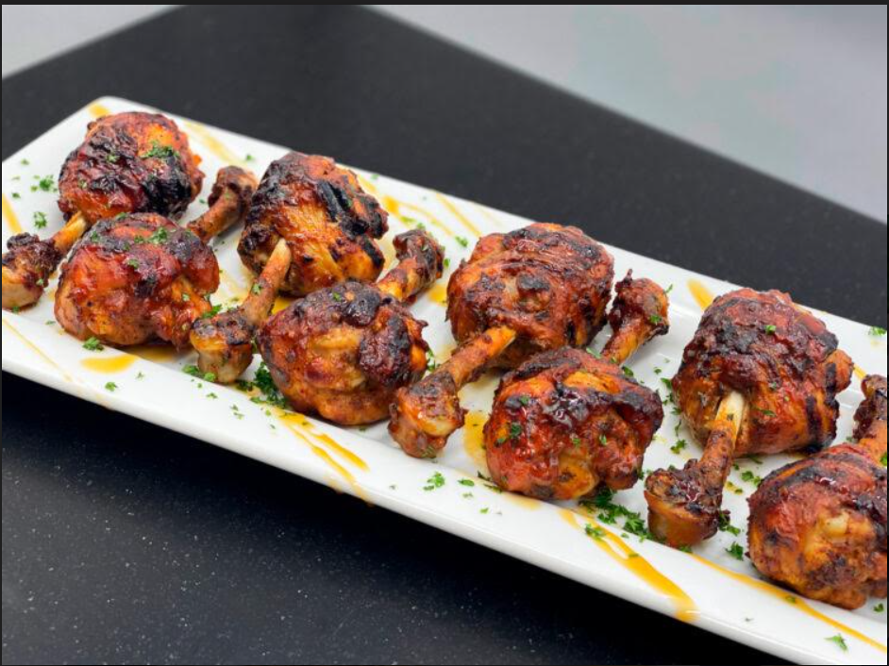

Samosa:

Calories:262

Proteins:1.4 g

Carbohydrates: 7.9 g

Fats:6 g

Cholestrol: 9 g

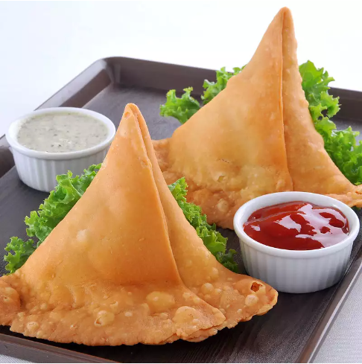

Shawarma:

Calories:517

Proteins:48 g

Carbohydrates: 30.9 g

Fats: 1.1 g

Cholestrol: 64.6 mg

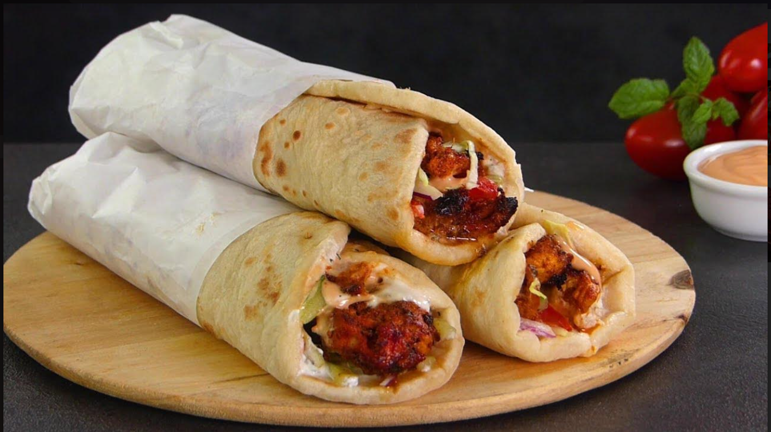

Solid junk foods

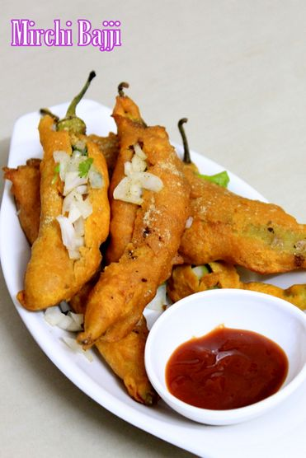

Chilli fritters

Totale fats- 7%

Carbohydrates – 5%

Protein – 3%

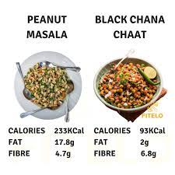

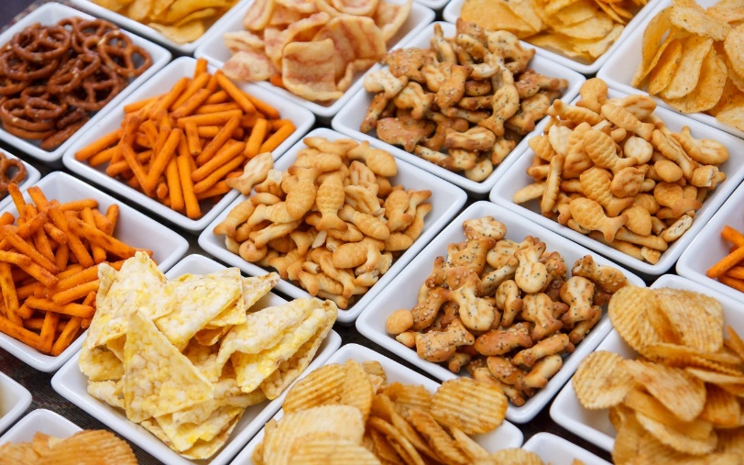

Snacks

Carbohydrates- 3%

Protein-2%

Dietry fibre – 2%

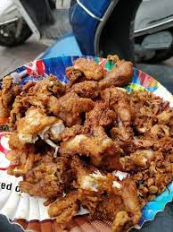

Chicken fry

Fats-7.5g

Protein – 16.5g

carbohydrates – 0.0g

Liquid junk foods-

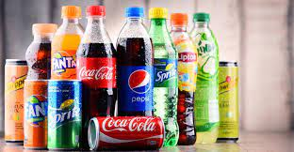

Soft drinks

Fats – 0%

Sodium – 2%

Carbohydrates -16%

protein – 0%

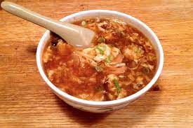

Sour soups-

Cholestrol – 21mg

Magnesium – 9mg

Choline – 39.9mg